Student name: Steven Xie

Student number: 998979627

Program & Department: MEng MIE

# Homework 1

Problem 1.

1. Given X is uniformly distributed in [2,8]

θ = E[(X - 4)+] = P(2≤X≤4) × 0 + P(4<X≤8) × E[(X-4)]

= $\frac{4-2}{8-2}$ × 0 + $\frac{8-4}{8-2}$ × (E(X) -4)

= $\frac{2}{3}$ $×(\int_{4}^{8}{\frac{x}{8-4}}$– 4)

= $\frac{4}{3}$

1. Shown in code

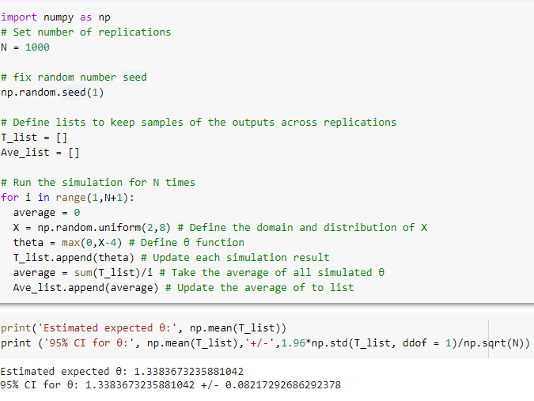

1. In the plot we can see that the average of simulated θ converge to the computed E(X) = 1.33

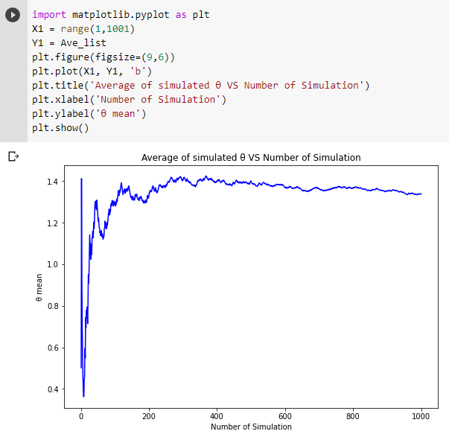

Problem 2

(a). Shown in code. With 1 replication before T = 1000 the average number of functional components is 1.156.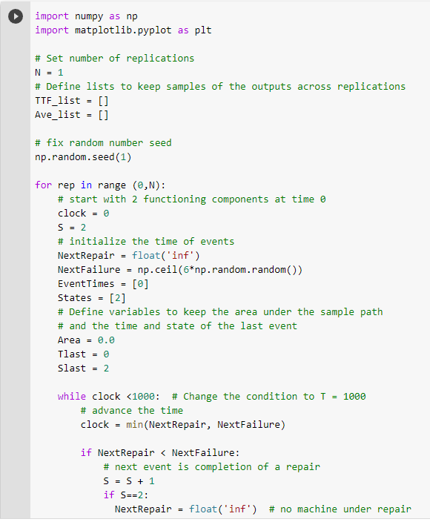

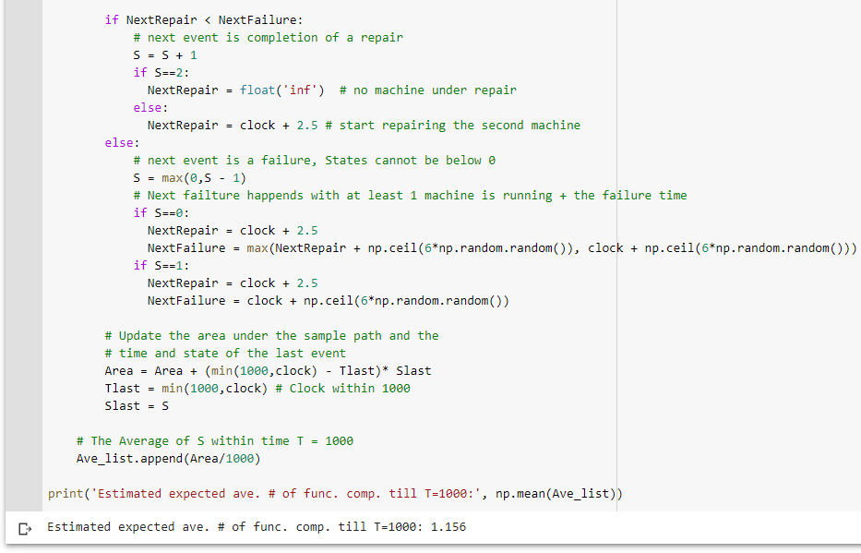

(b). Model is almost identical as in (a) except that the Slast is replaced with A_t which is a binary variable. The expected average system availability time till T=1000 is 82.5%.

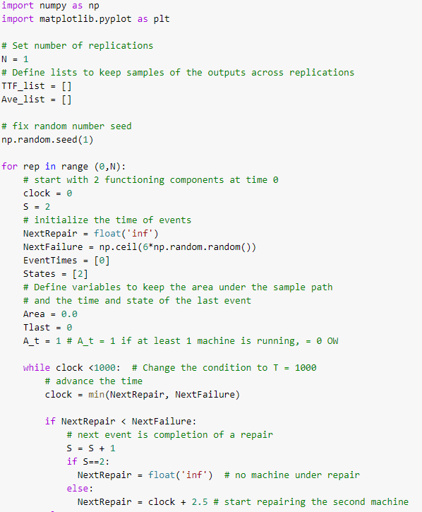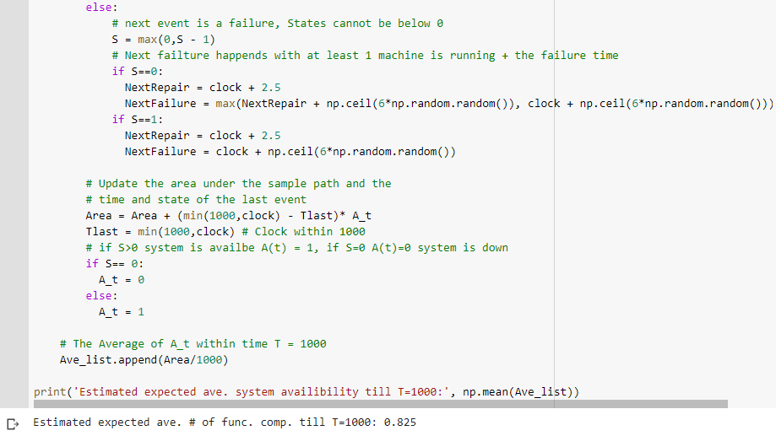

(c). The estimates for T=1000 and T=3000 are very close (1.156 vs 1.161 and 82.5% vs 83.4 %). Therefore, when we simulate a system with a relatively large number, the estimations of the average of the simulations will converge.





Problem 3

Code Shown below.

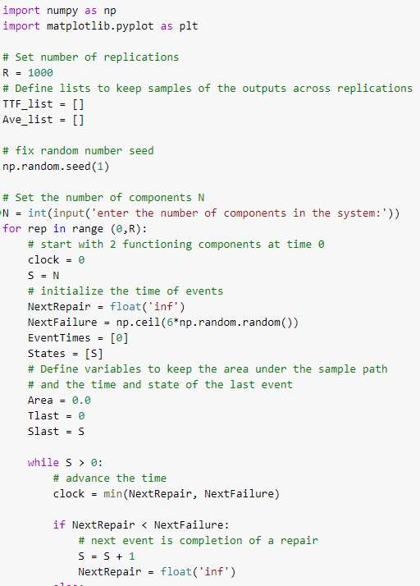

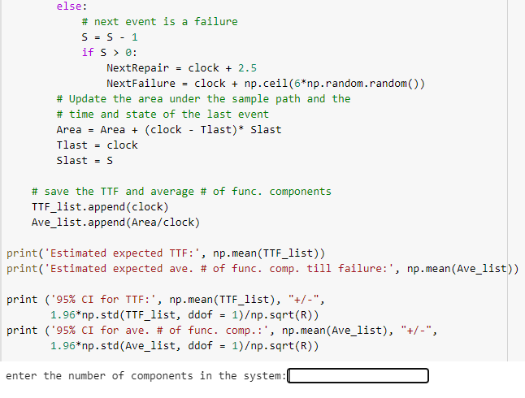

Result shown below:

N = 2: TTF = 13.927 +/- 0.727

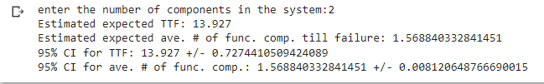

N = 3: TTF =24.527 +/- 0.989

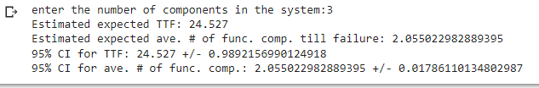

N = 4 TTF= 34.725 +/- 1.197

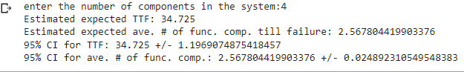

Problem 4

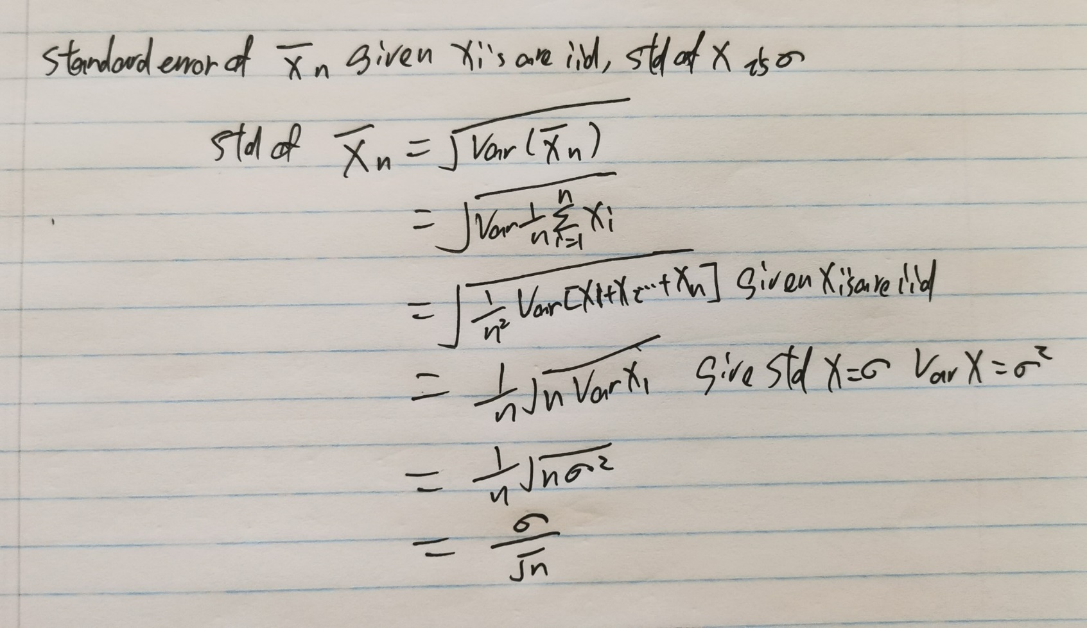

Problem 5

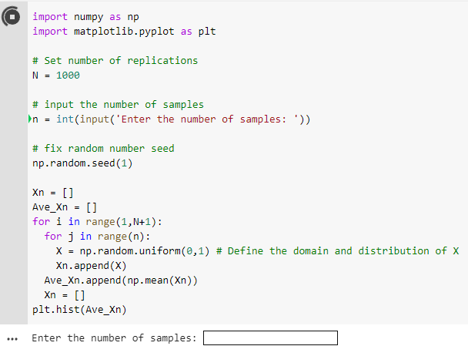

n = 1 n= 2

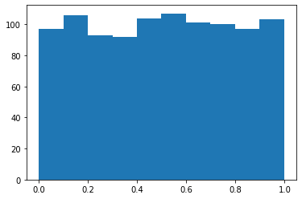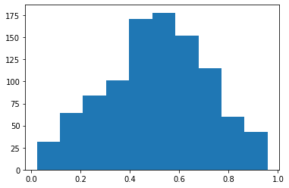

n = 30 n=500

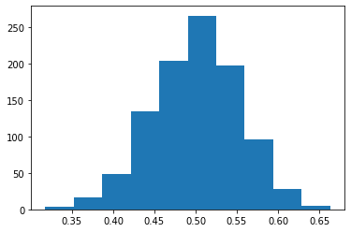 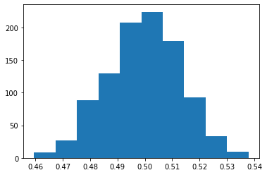

As n increases, the means of samples become closer to the expected value of mean = 0.5, the variances become smaller. The distribution of means of samples become more likely to be a normal distribution with decreasing variance as n increases.